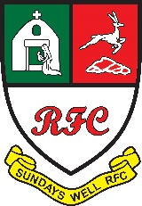
Annual General Meeting
Thursday 26th May 2022 at 19:30
Agenda

- Minutes of A.G.M. 2021
- President’s Report
- Hon. Treasurer’s Report
- Youth Officer’s Report
- Captain’s Report
- Mixed Ability Rugby Report
- Election of Officers

- President
- Senior Vice President
- Junior Vice President
- Chairman
- Hon. Secretary
- Hon. Treasurer
- P.R.O.
- House Officer
- Membership Manager
- Director of Rugby
- Club Captain
- Head Coach
- Appointment of Auditors
- Approval of Club Trustees
- Any Other Business

Any Nominations or Notice of Motions must be sent to the Hon. Secretary before 12th May 2019

