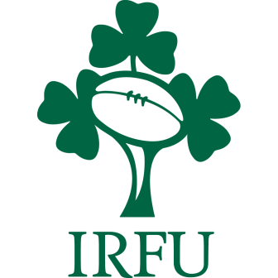
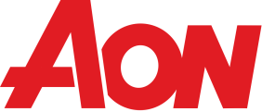
Irish Rugby Football Union
Compulsory Group Personal Accident Scheme for Clubs
Application 2021/2022

N.B. This scheme is compulsory for all affiliated clubs including teams affiliated to the Irish Women’s Rugby Football Union. To ensure cover is in operation this form must be completed and returned to your branch along with the appropriate premium. Any cheques should be made payable to your Branch and crossed. It is important you respond to all questions.

(1) Name and address of Club __________________________________________________________

(2) IRFU Branch _______________________________________________________________________

(3) Name of club secretary ______________________________________________________________

(4) Total number of playing members - Adult Male_____________________________________

Youth (male/female, age up to & incl. 21) __________ Adult Female __________

(5) Max number Adult teams (male/female) ________________________________________________

(6) Number Youth teams incl. under 21’s __________________________________________________

(7) Name of mini teams ________________________________________________________________

Premium Enclosed (no charge for Youth, Under 21s or Mini Teams)

No. of Adult Teams __________@ €1,584 per Adult team = Total € ______________________

Declaration
We desire to insure in the terms of the contract entered into by the IRISH RUGBY FOOTBALL UNION as arranged by Aon. We do hereby warrant that the above statements and this Declaration are fully and truly made and that all the persons to be insured are to the best of our belief in good health and we hereby agree that this Declaration shall form the basis of the contract so far as this Club is concerned.

Date ................................................................. Signed ............................................................................
(for the Club)
This form must be returned to your Branch URGENTLY

Aon Ireland Limited t/a Aon, Aon Risk Solutions, Aon Affinity, Aon Claims Management, The Bar of Ireland Financial Services and Unity Insurances, is a private company limited by shares and is regulated by the Central Bank of Ireland. Registered in Ireland No. 5103 Registered Office: Metropolitan Building, James Joyce Street, Dublin 1. DO1 K0Y8

Aviva Insurance Ireland DAC, trading as Aviva, is authorised by the Prudential Regulation Authority in the UK and is regulated by the Central Bank of Ireland for conduct of business
rules. Registered Branch Office in Ireland no.900175. Registered Branch address 1 Park Place, Hatch Street. Dublin 2. Registered in Scotland, no.2116 , Registered Office Pitheavlis, Perth PH2 ONH.

